**Section 1: Acquiring Data**

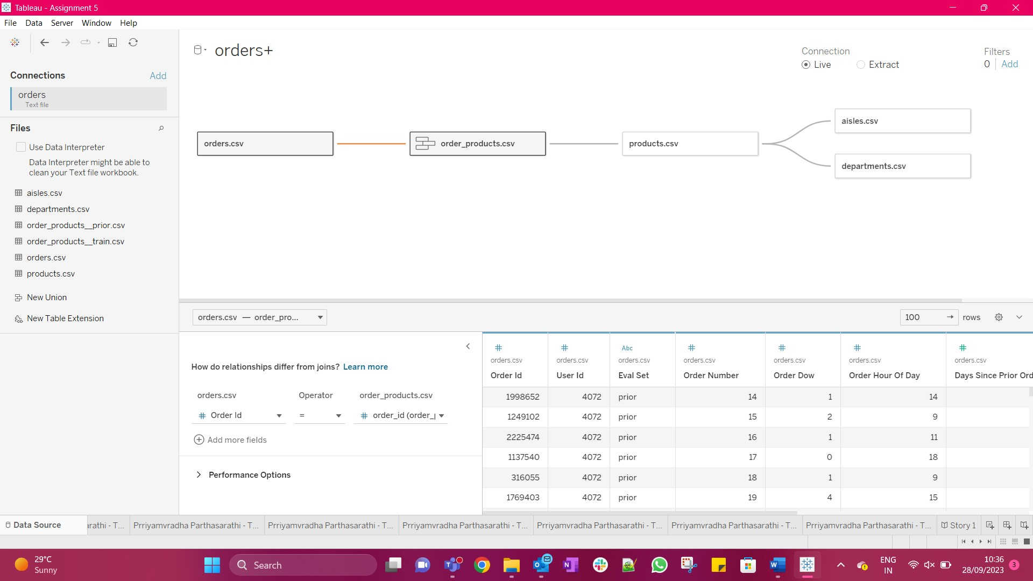

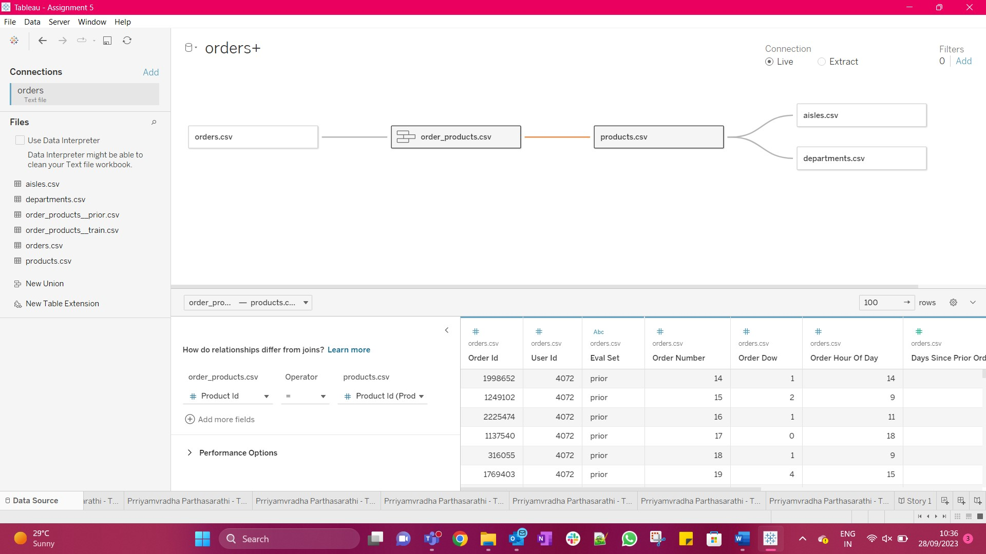

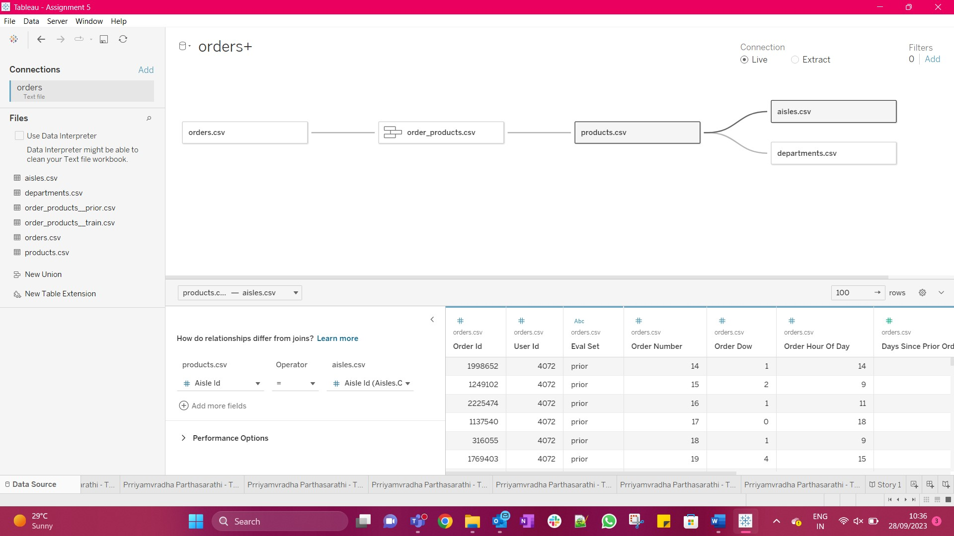

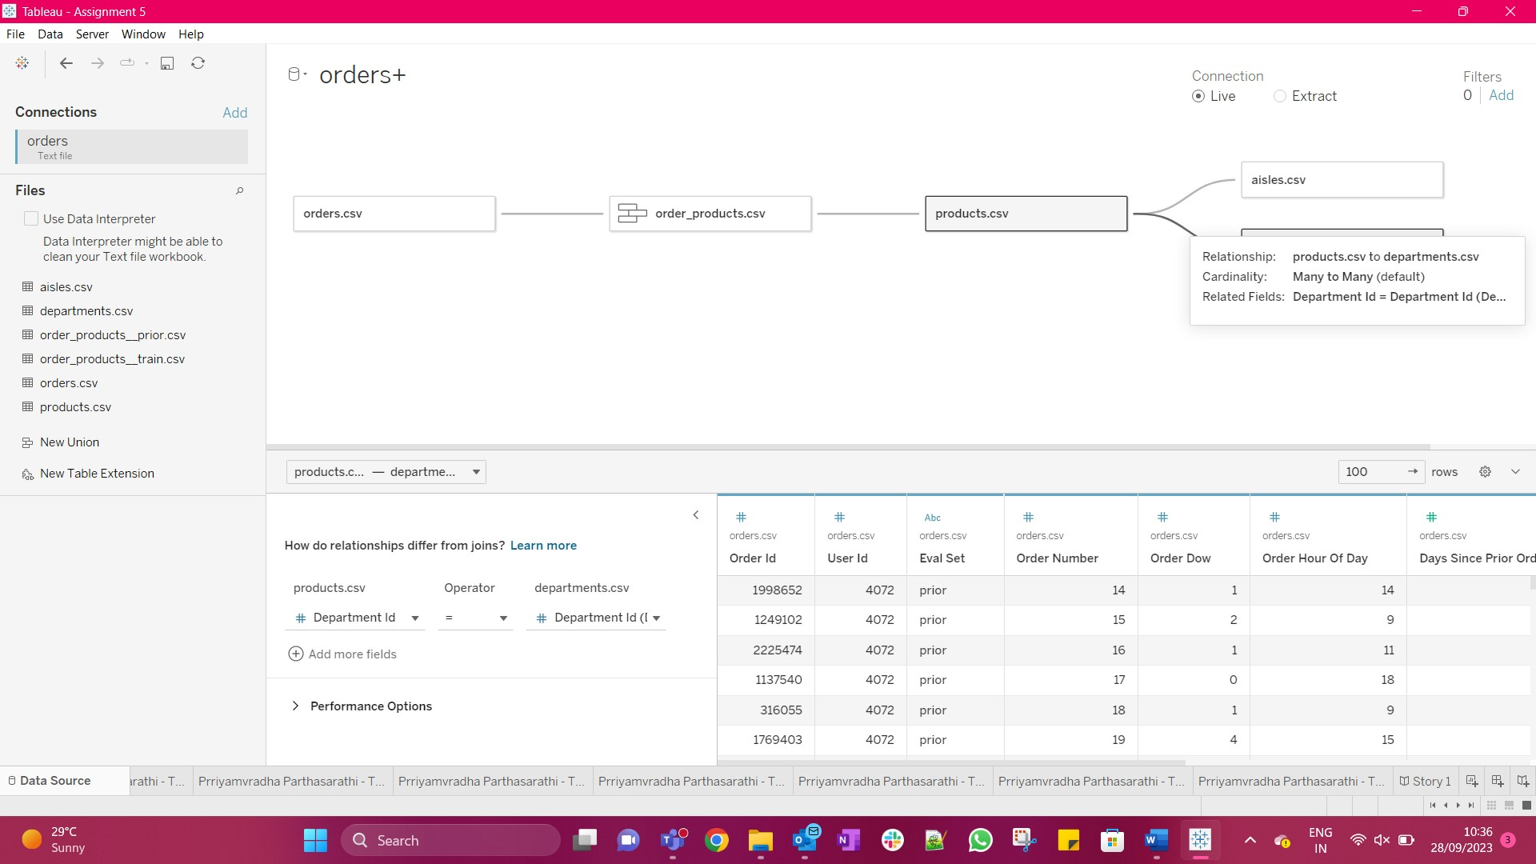

**Section 2: Defining the Audience**

The primary groups are:

* Senior Management
* Sales Team
* Customers
* Marketing Team
* Store owners
* Customer care
* Human Resources
* Competitors

The executive role or positions are:

* Senior Management
* Sales Team
* Marketing Team
* Store owners
* Human Resources

The experience of the audience is shallow because the audience do not work in the Technology Teams and do not know much about the core data analysis

The scope of the audience is narrow because each of the audience is from a different department and would not communicate with other departments in terms of making any decision.

The audience's primary interests lie in understanding the most and least selling products, pinpointing the busiest sales hours, determining the most profitable items, and identifying the most lucrative days and hours

1. Leadership should formulate strategies to boost sales of less popular products.
2. Optimize operations during peak hours and on high-traffic days of the week.
3. Ensure popular aisles maintain consistent stock levels to prevent shortages.
4. Develop tailored strategies for products with lower sales to drive increased market performance.

This comprehensive overview empowers the company to refine production and sales strategies, ultimately ensuring sustained profitability.

The primary goal is to enhance customer service and maximize profits by revitalizing the sales performance of less popular products, all while capitalizing on the success of best-sellers.

**Section 3: Data Analysis**

1. **Service Analysis**
2. Analyzing the Busiest Days of the Week (dow)

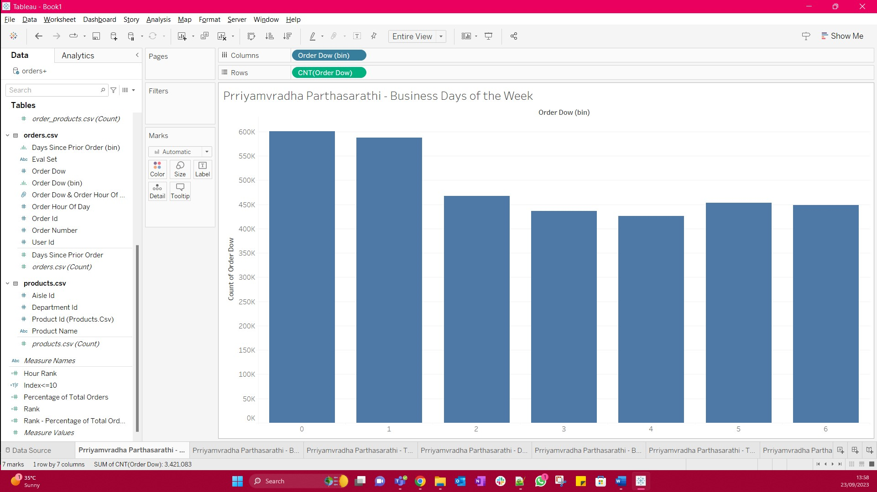

Saturday (Day 0) and Sunday (Day 1) are the two busiest days of the week.

1. Analyzing the Busiest Hours

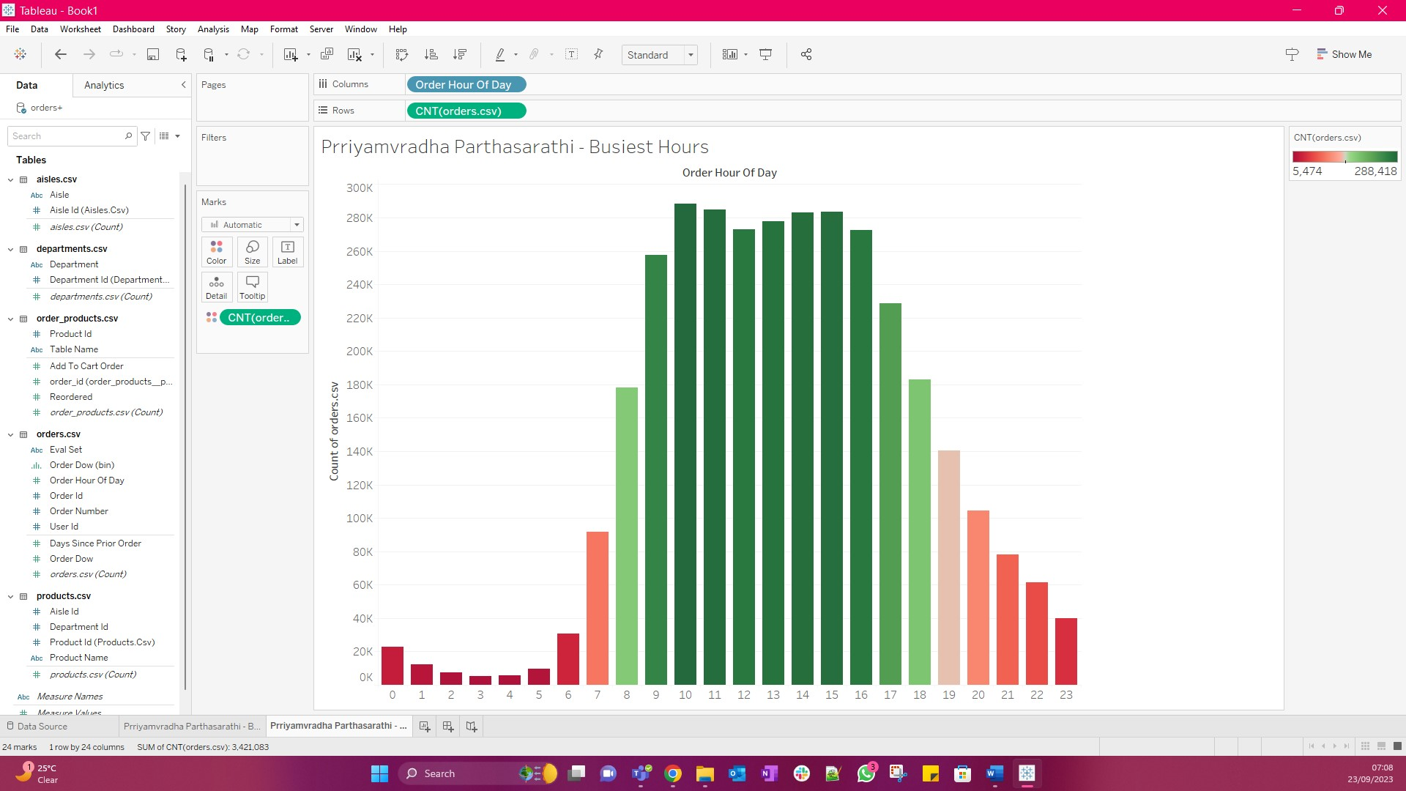

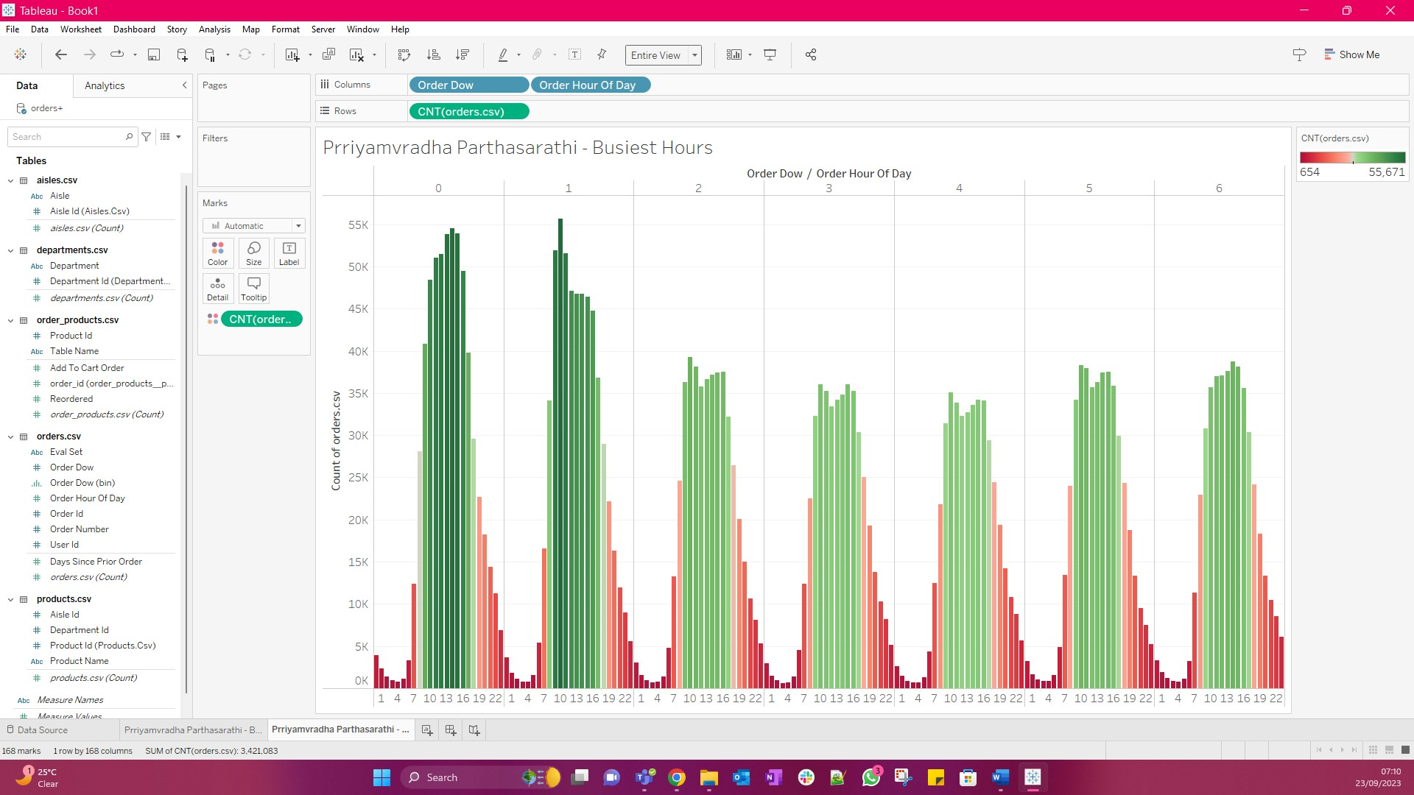

The busiest hours are from 8 to 18. The top 11 busiest hours are 10,11, 15, 14, 13, 12, 16, 9, 17, 18, 8.

1. Top 10 Products in the Busiest Hours

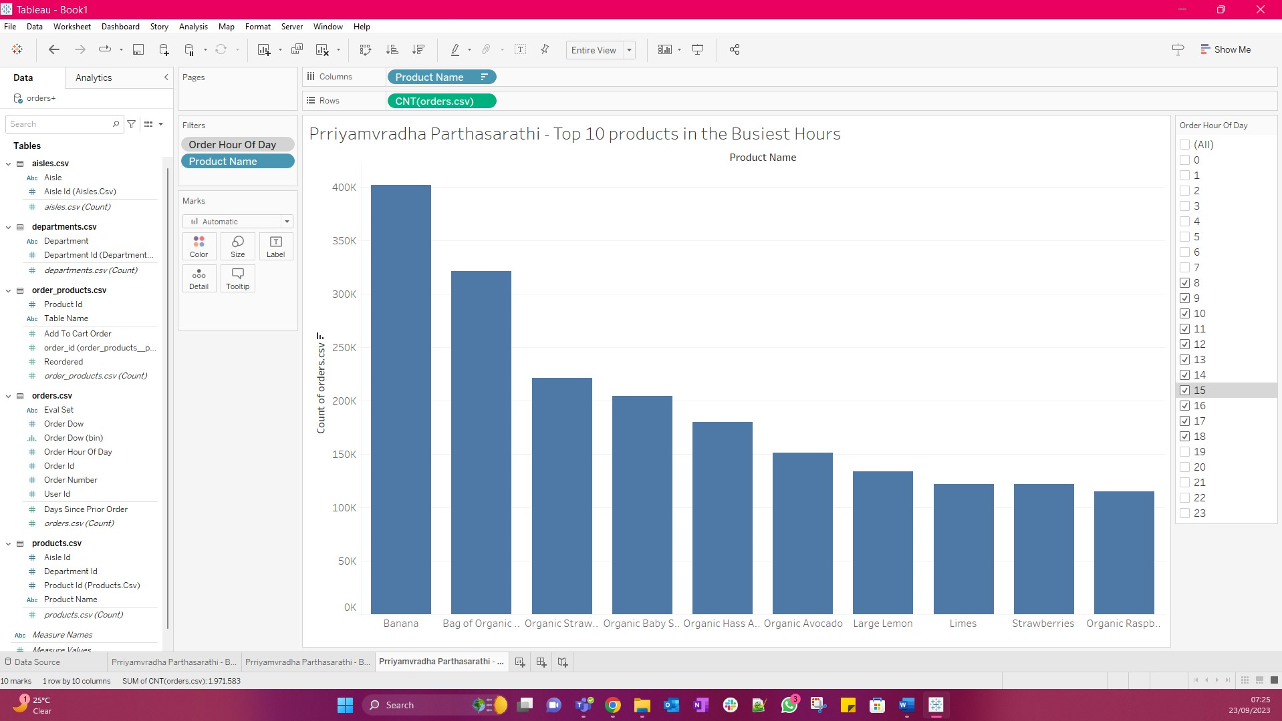

Bananas are the most sold product in the busiest hour.

1. Days Since Prior Order. How long after their previous order, do customers order again?

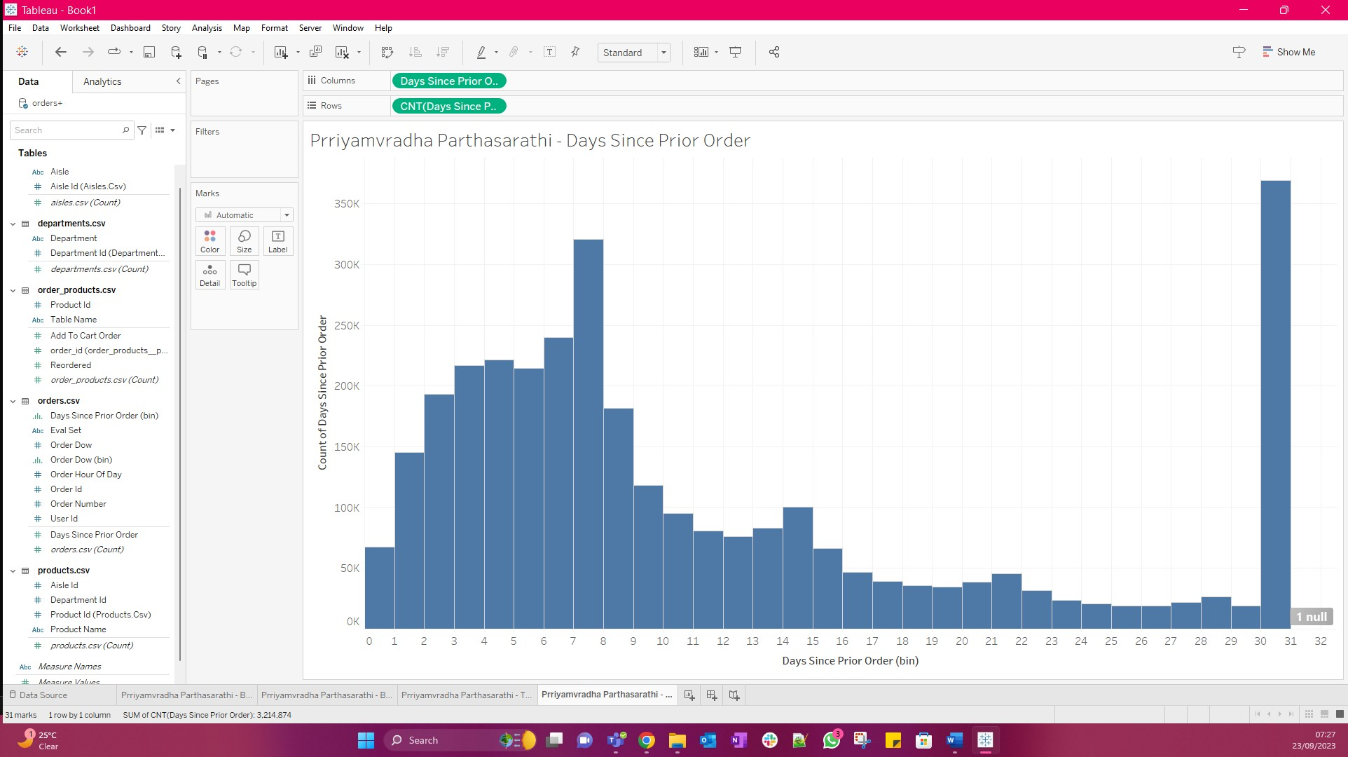

Customers are most likely to order again after 30 to 31 days or 7 to 8 days.

1. **Product Analysis:**
2. Best Selling Products

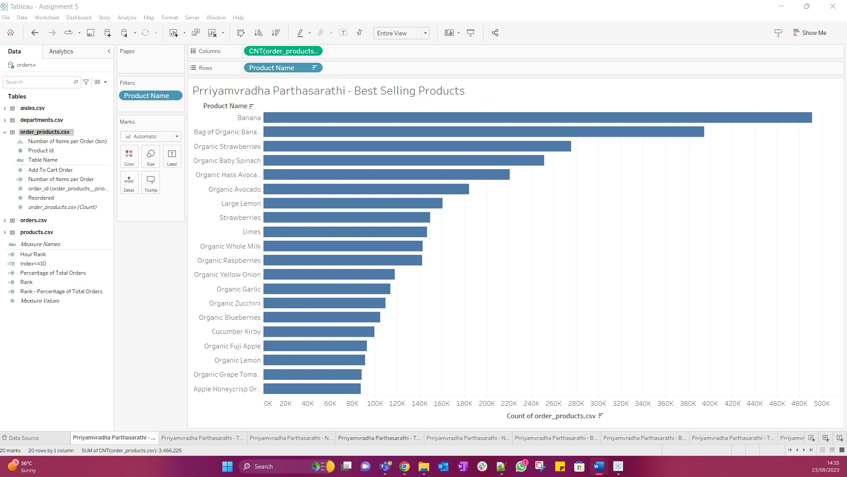

The Top 3 bestselling products are Banana, Bag of organic Bananas, Organic Strawberries.

1. Top 10 Products on First Order. What are the top products that customers will most likely buy while ordering for the first time?

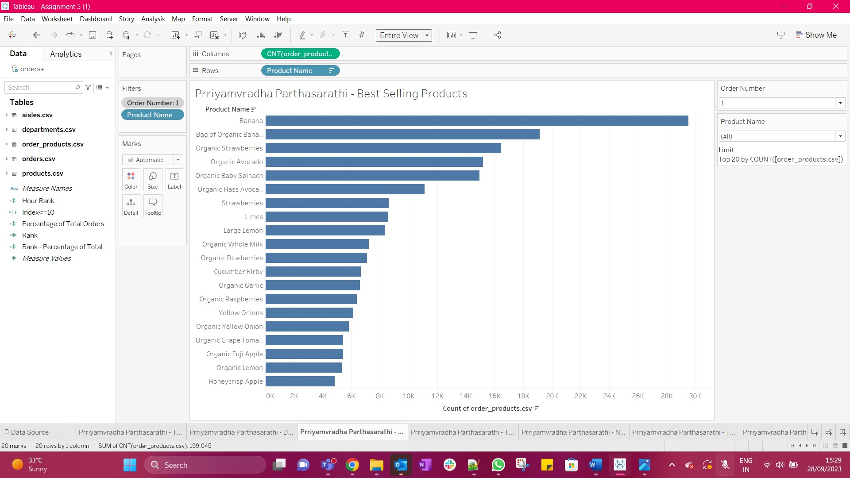

1. Top 10 Reordered Products in terms of their probability of being reordered.

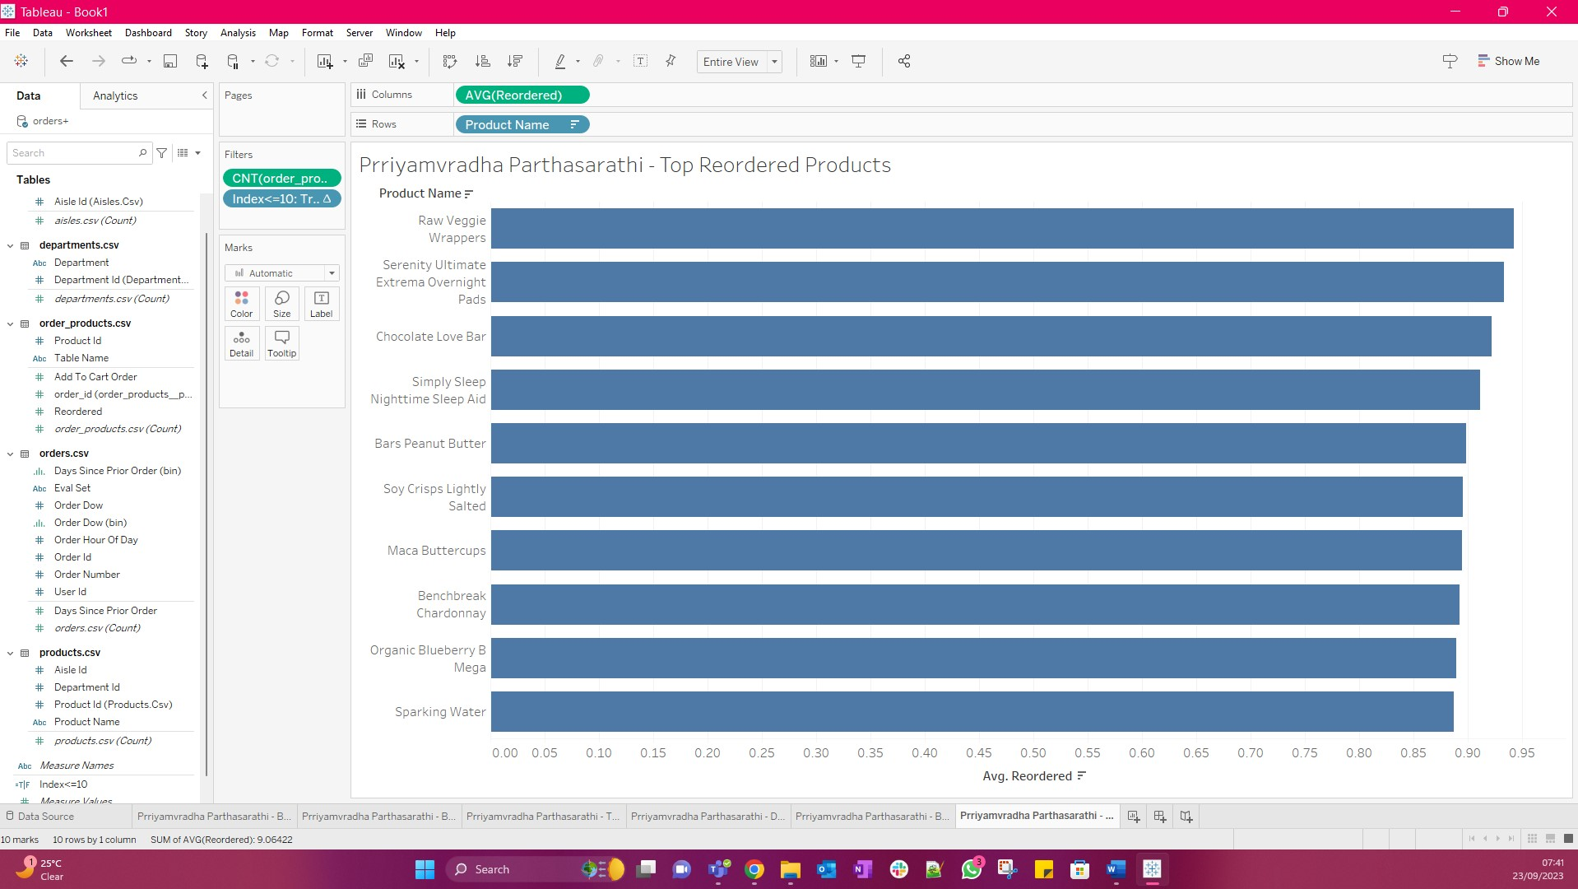

The most reordered product is Raw Veggie Wrapper and its probability of being reordered is 0.94203

1. Number of Items Purchased in an Order

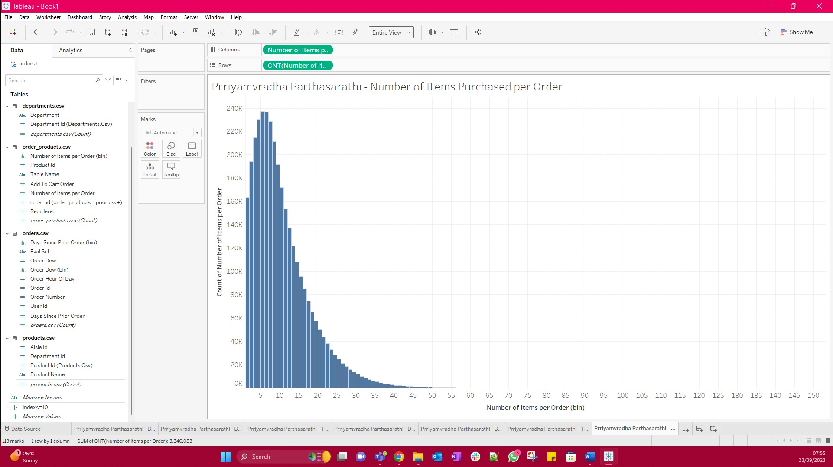

Customers most often order 237,225 items.

1. **Category Analysis:**
2. Tree map of Aisles and Products – Most Popular Aisles

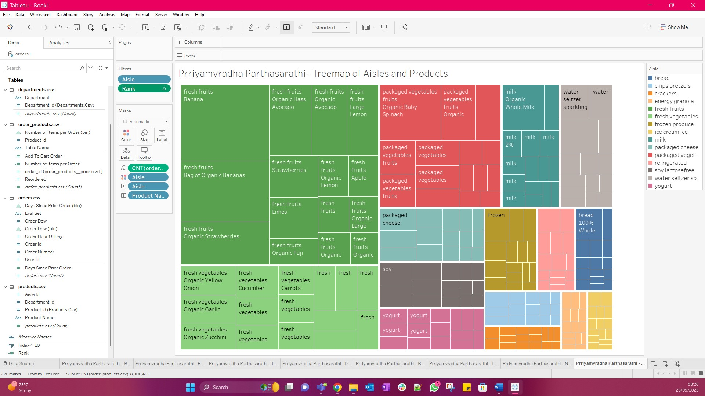

The top 3 aisles that customers mostly order from are Fresh Fruits, Fresh Vegetables and Packed Vegetables

1. How often (frequency) are products from each of the departments sold.

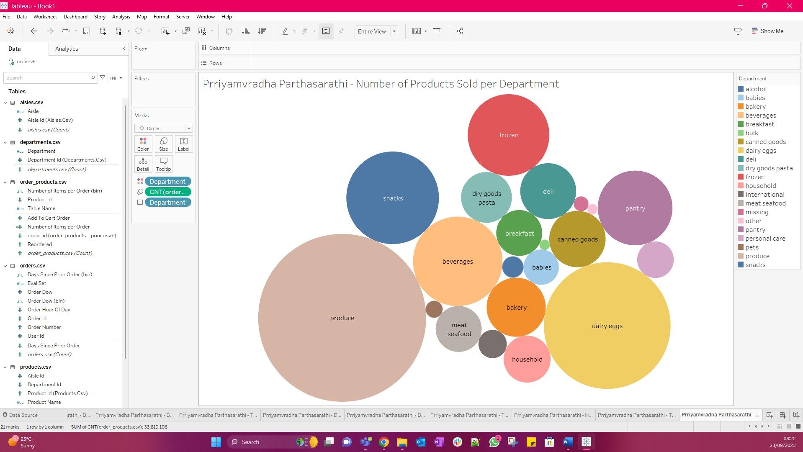

The top 2 departments with the highest number of products sold are produce and dairy eggs.

1. **Top Products**
2. Ranking each hour of each day of the week based on number of orders placed.

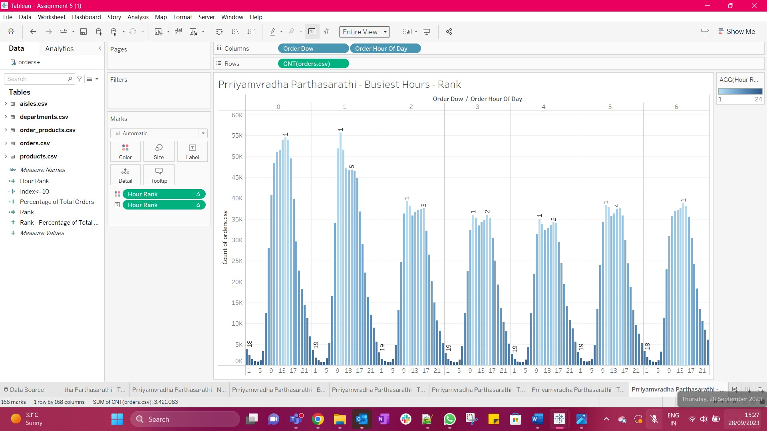

1. Grouping Order Hour of Day and Order DOW

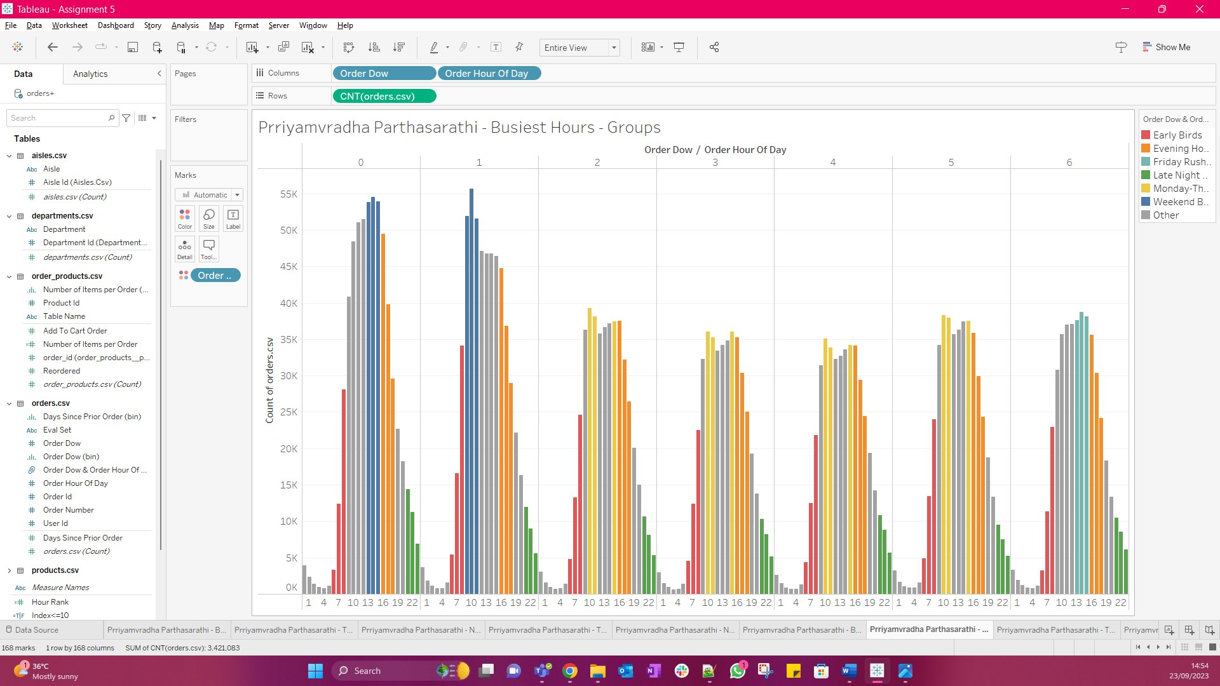

1. Analyzing the top products ordered per group.

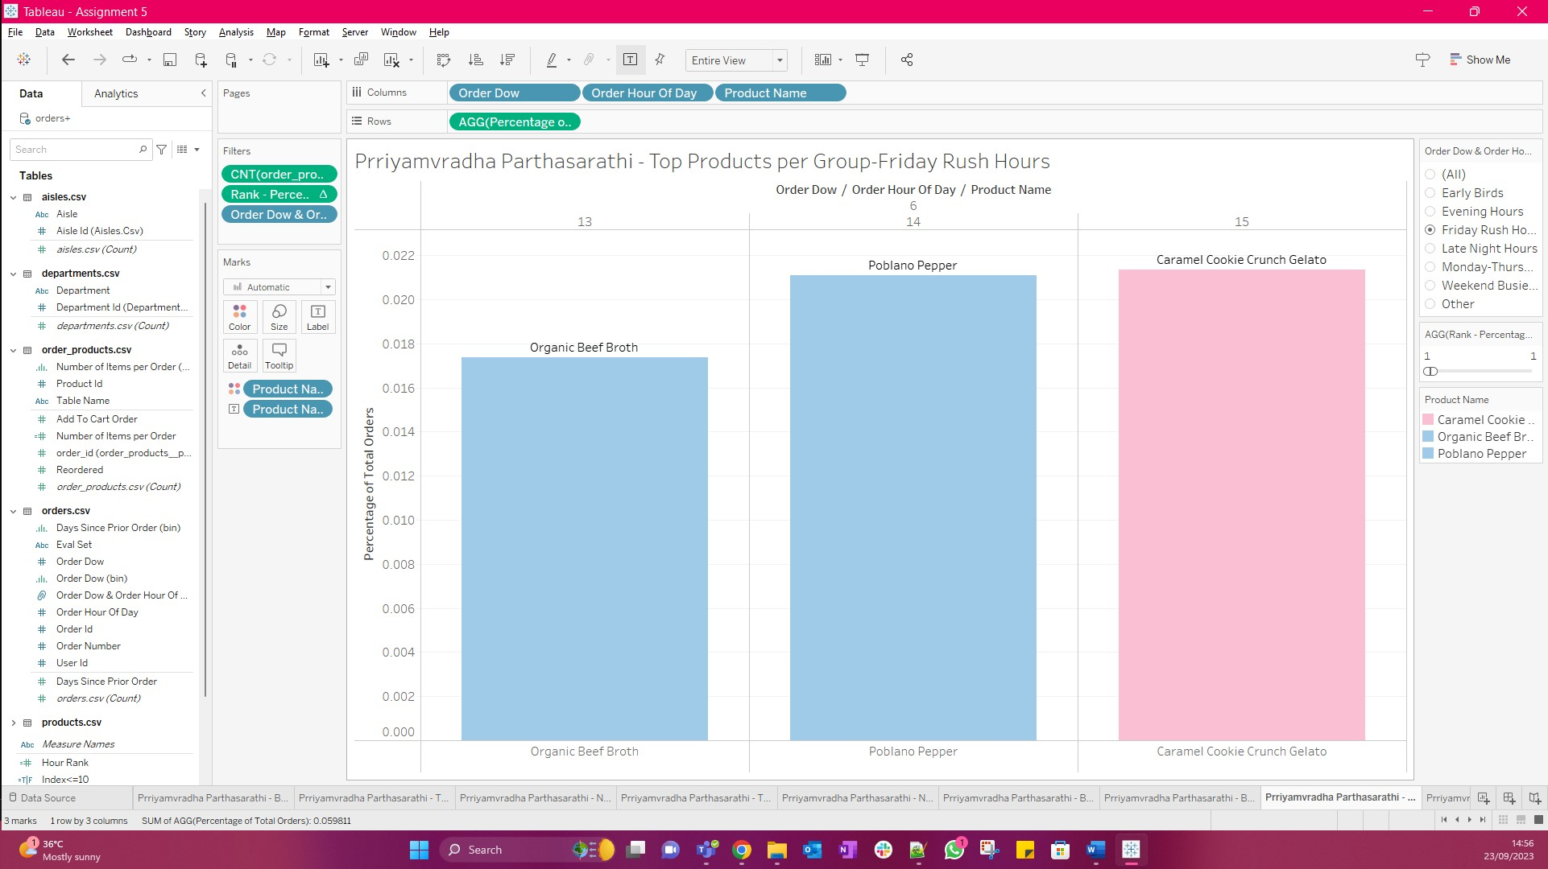

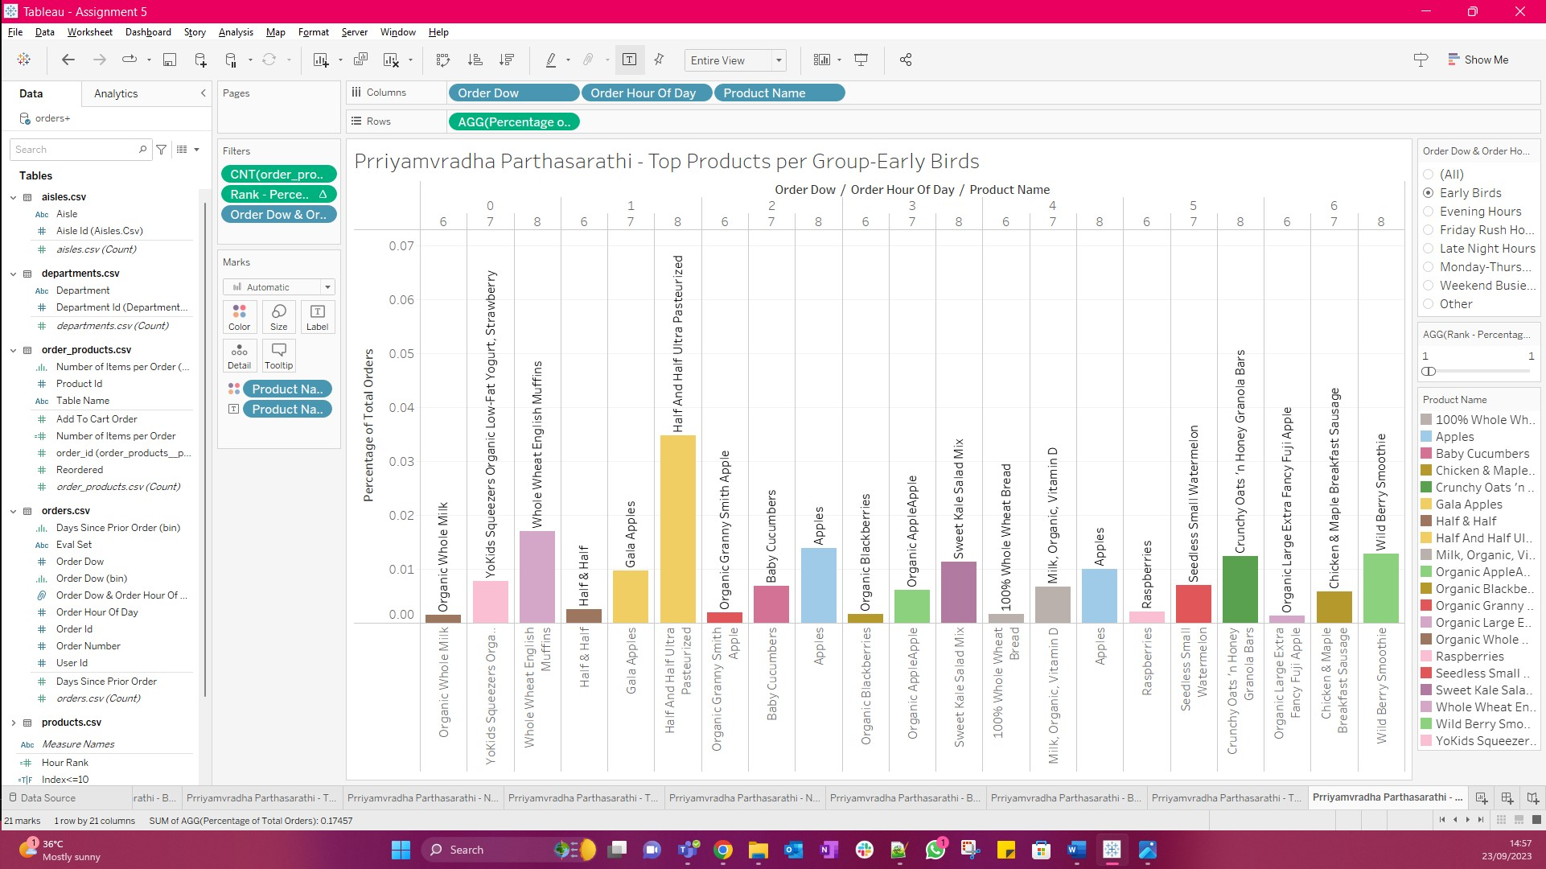

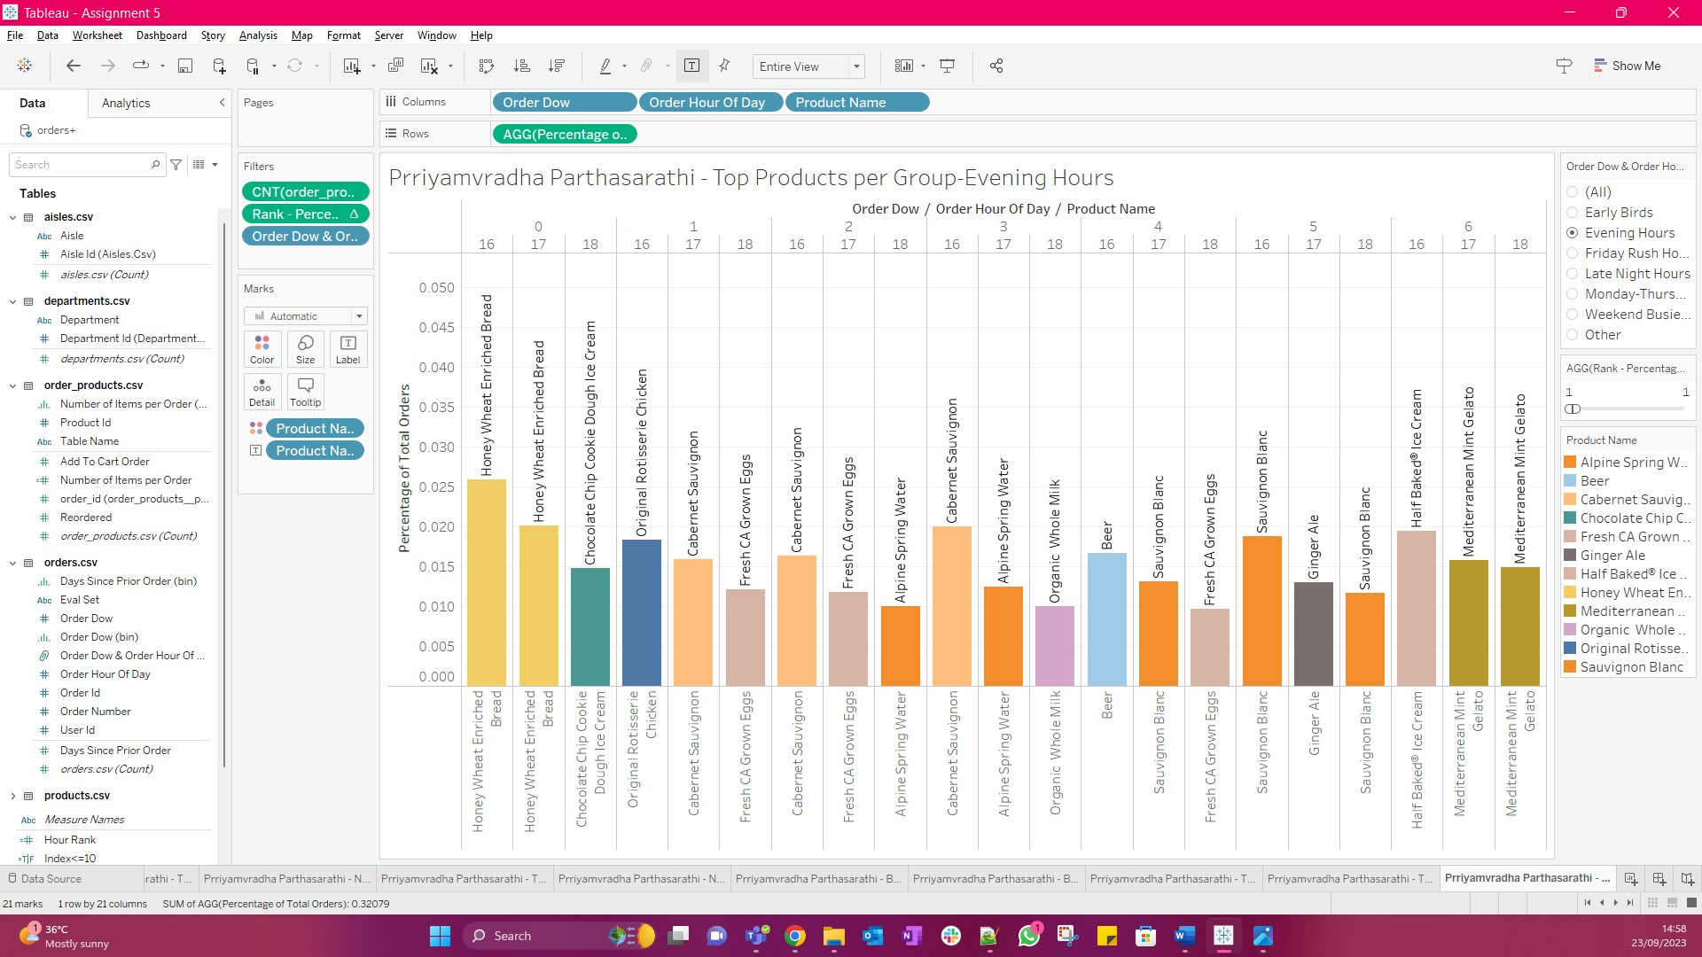

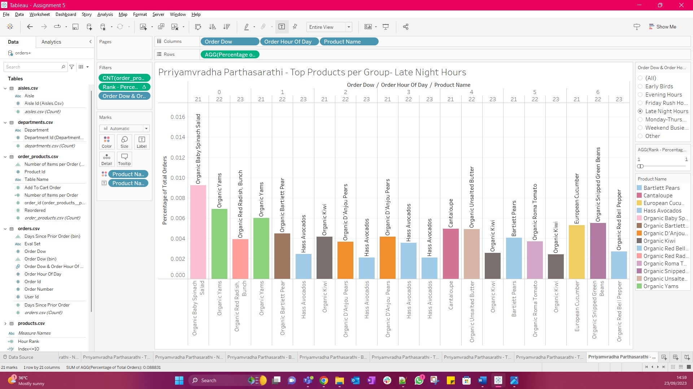

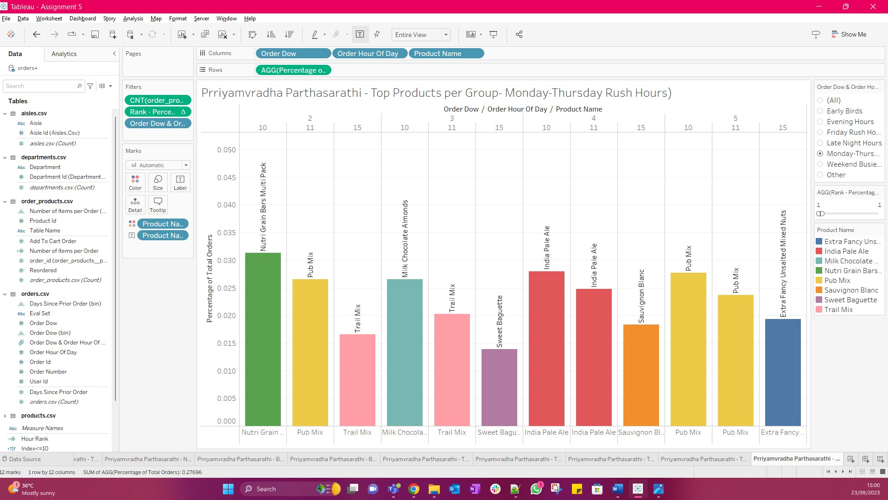

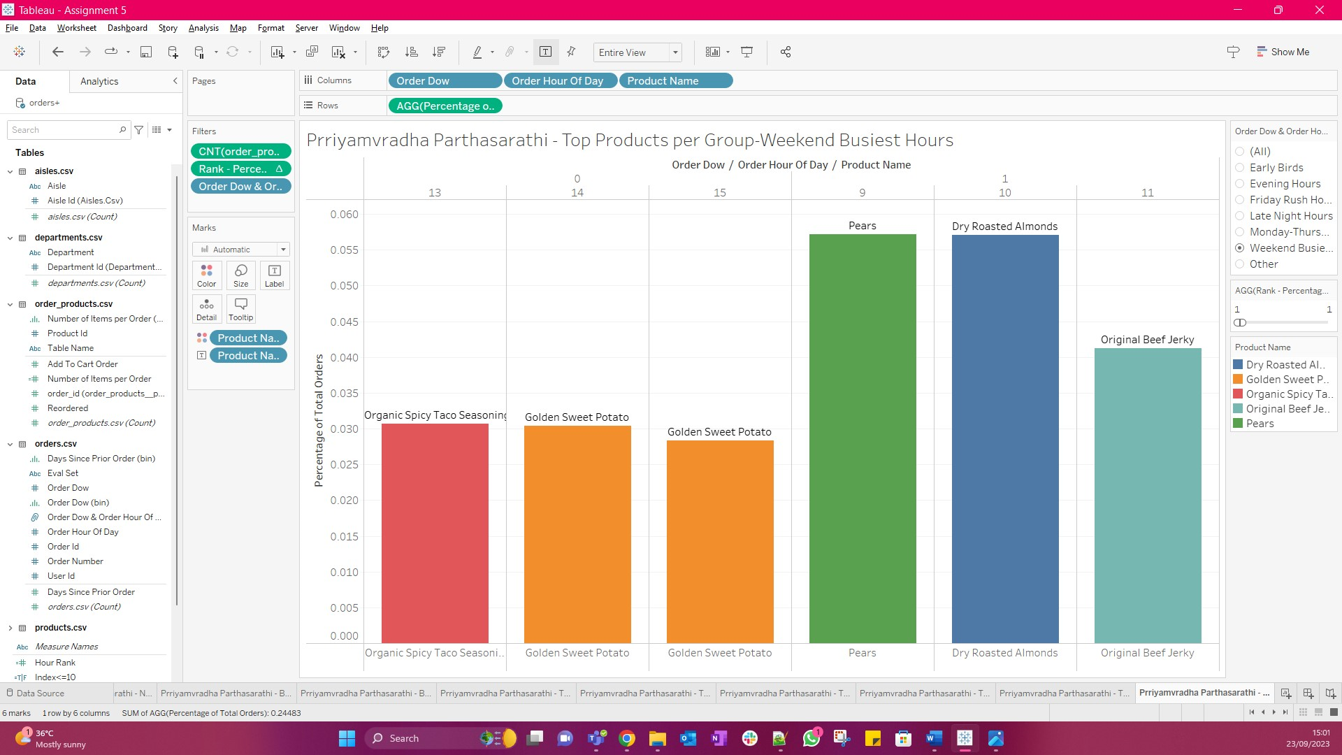

**Section 4: Curate your Views**

Removed the extra worksheets leaving only the below tabs for use:

* Busiest Hours
* Busiest Days of the Week
* Days Since Prior Order
* Number of Items Purchased
* Best Selling Products
* Treemap of Aisles and Products
* Early Birds
* Evening Hours
* Friday Rush Hours
* Late Night Hours
* Monday -Thursday Rush Hours
* Weekend Busiest Hours

**Section 5: Organizing the Storyline with Storyboarding**

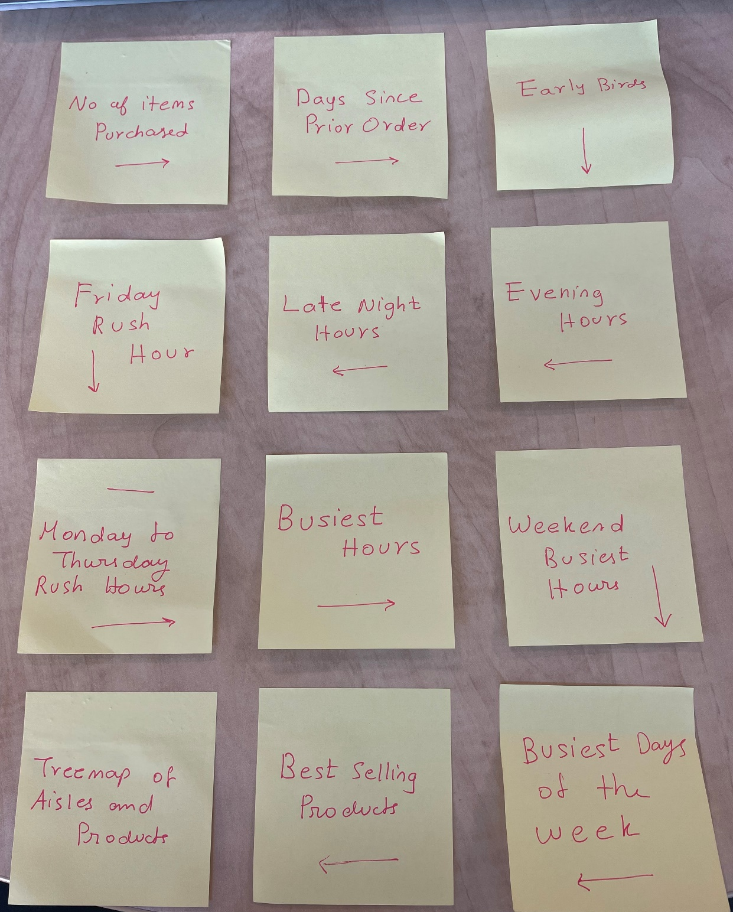

The storyline approach that I will be using is Freytag’s Pyramid

1. Number of Items Purchased 🡪 **Beginning (Exposition)**
2. Days Since Prior Order 🡪 **Beginning (Exposition)**
3. Top Products per Group - Early Birds 🡪 **Rising Action**
4. Top Products per Group - Evening Hours 🡪 **Rising Action**
5. Top Products per Group - Late Night Hours 🡪 **Rising Action**
6. Top Products per Group - Friday Rush Hours 🡪 **Rising Action**
7. Top Products per Group - Monday -Thursday Rush Hours 🡪 **Rising Action**
8. Busiest Hours 🡪 **Climax**
9. Weekend Busiest Hours Climax 🡪 **Climax**
10. Busiest Days of the Week 🡪 **Climax**
11. Best Selling Products 🡪 **End (Resolution)**
12. Treemap of Aisles and Products 🡪 **End (Resolution)**

**Section 5: Creating a Story in Tableau**

The Rhetoric that has been used in this story is Logical Rhetoric. Because the storyline scenario considered here is more of a behavioral scenario.

1. Quantifying Consumer Choices
2. Temporal Shopper Patterns
3. Dawn's Preferred Picks
4. Twilight's Treasures
5. Nocturnal Consumer Champions
6. Weekend Worthy Winners
7. Midweek Market Leaders
8. Pinnacle of Activity
9. Weekend Shopping Surge
10. Weekly Shopping Peaks
11. Championing Consumer Choices
12. Visualizing Store Dynamics

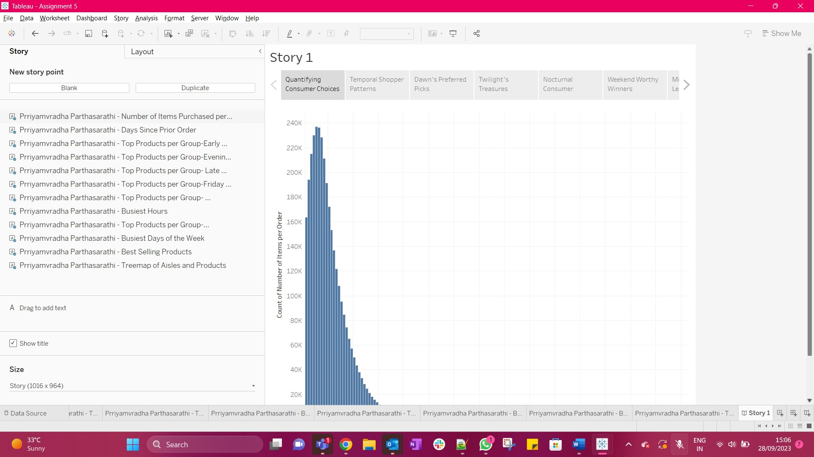

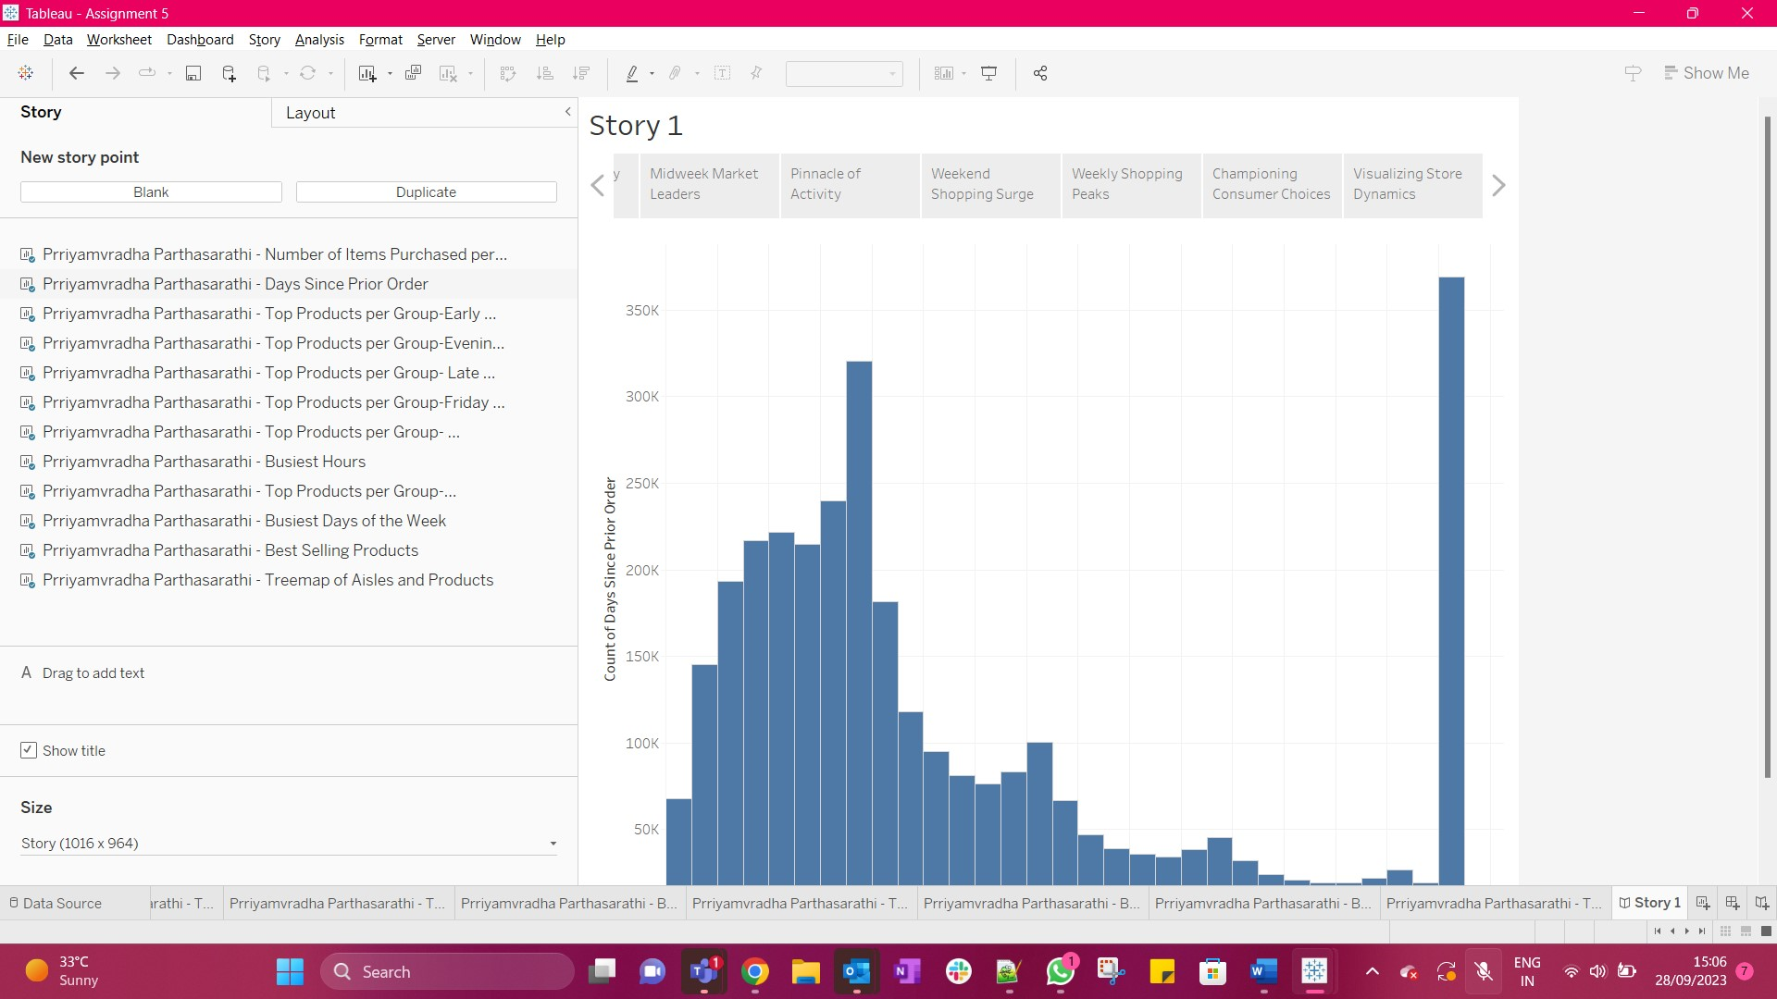

**Section 7: Formatting the Story**

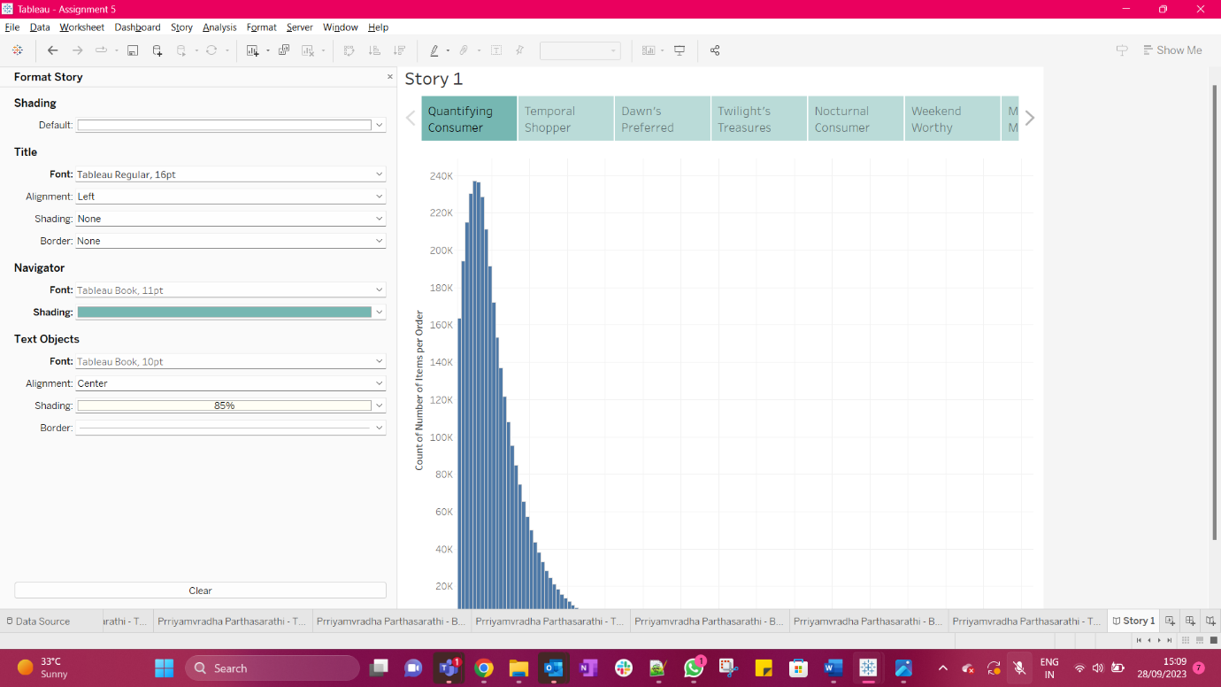

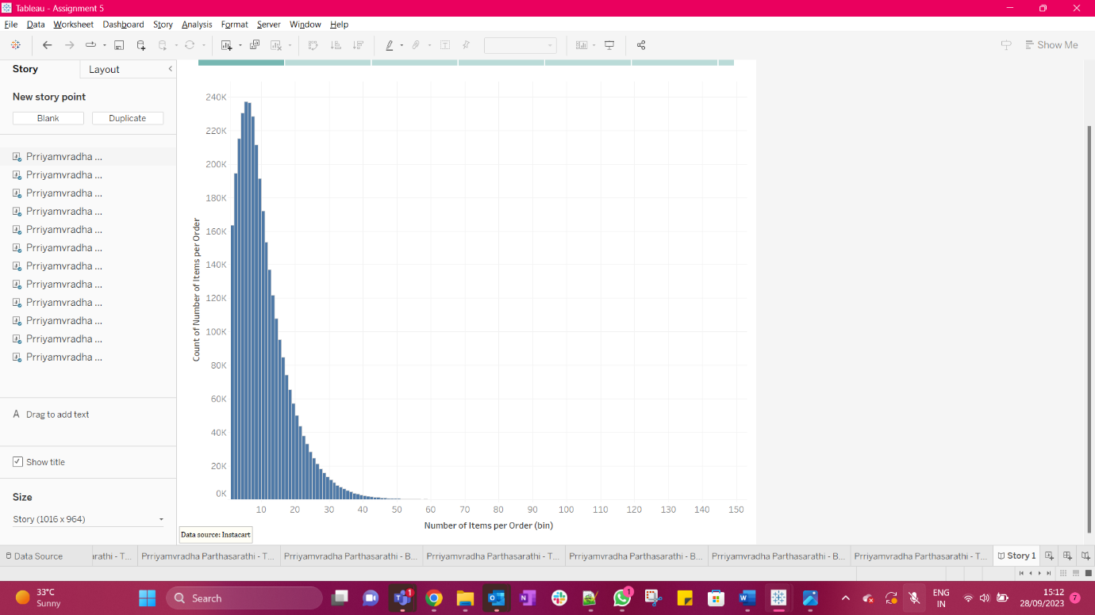

Screenshot of both the worksheet and the first view in the story attached as the edited axis and the title did not appear in the storyboard.

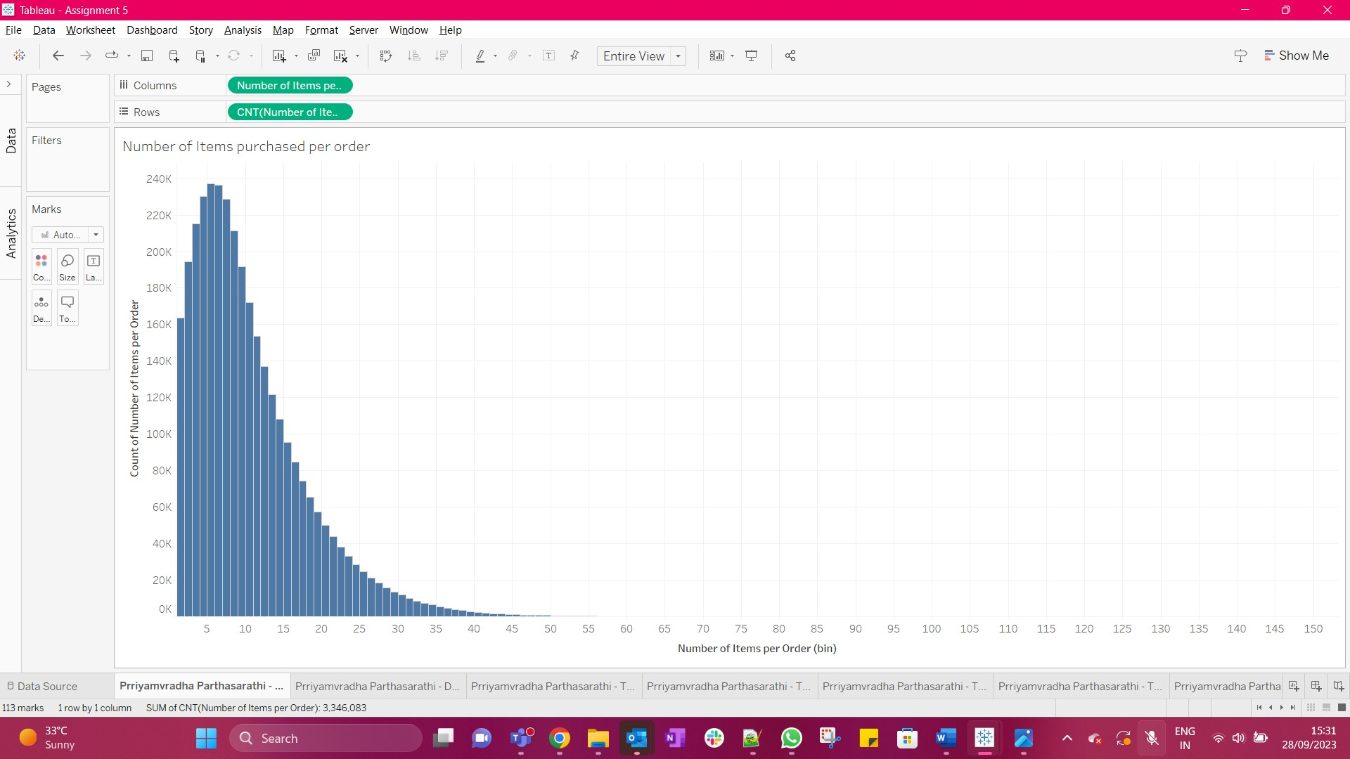

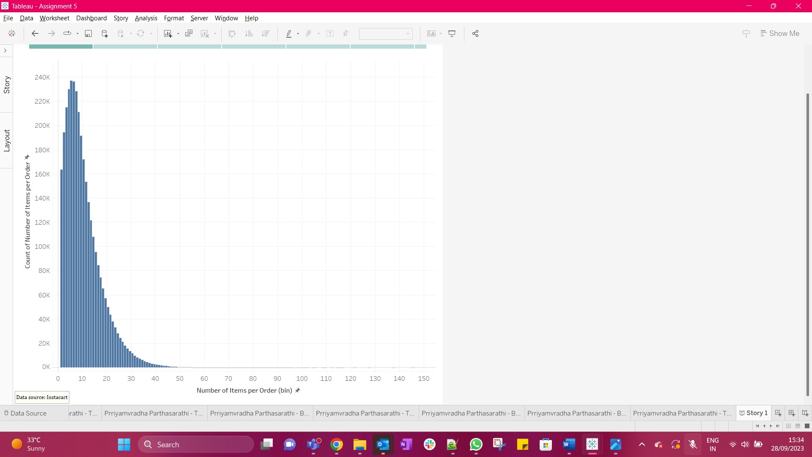

Screenshot of both the worksheet and the last view in the story attached as the edited axis and the title did not appear in the storyboard.

